TDS Telecom Goes Live with Velocix for IP Video Streaming and Cloud DVR Services

Growing operator completes phase 1 of a network-wide multi-screen video project

Cambridge, UK – June 1, 2020 – Velocix and TDS Telecom (TDS®) today announced the successful roll-out of IP video streaming and Cloud DVR services to consumers in central Oregon, USA, completing the first phase of a network-wide project to upgrade the entertainment experience available to TDS’s 1.2 million connections. Branded TDS TV+, the new Android TV-based streaming video service is powered by Velocix’s suite of IP video products, including its CDN, origin server, and video recording solutions.

Using the new service, TDS subscribers can watch linear programming, video-on-demand, and personalised video recordings on a multitude of consumer devices, including TVs, PCs, mobile devices, and the most popular streaming media players. Consumers can enjoy more than 180 channels on their own schedule, as well as accessing an extensive library of on-demand and pay-per-view content. Additionally, internet-based offerings, including Netflix and YouTube, can be accessed directly through the new service.

Mark Barber, SVP of Network Operations at TDS, said: “We are excited to complete the first phase roll-out of our new TDS TV+ service with Velocix. Velocix’s integrated software platform enables TDS to deliver a more personalized and engaging entertainment experience on a wide range of consumer devices, which is critical to attracting and retaining video subscribers in our highly competitive markets.”

David Sharpley, CEO of Velocix added: “We are delighted that TDS has selected Velocix to power its next-generation IP video service offerings. Velocix’s carrier-grade content delivery solutions provide TDS with a flexible foundation for growth, enabling the company to bring innovative multi-screen services to its expanding base of premium video subscribers.”

The Velocix platform replaces two legacy cable systems and an established IPTV solution, unifying the network and integrating both managed and unmanaged video delivery. TDS TV+ will be made available to the entire TDS footprint in 2020, which includes consumers in 31 U.S. states.

Additional information about Velocix’s portfolio is available at www.velocix.com.

# ENDS #

Picture:

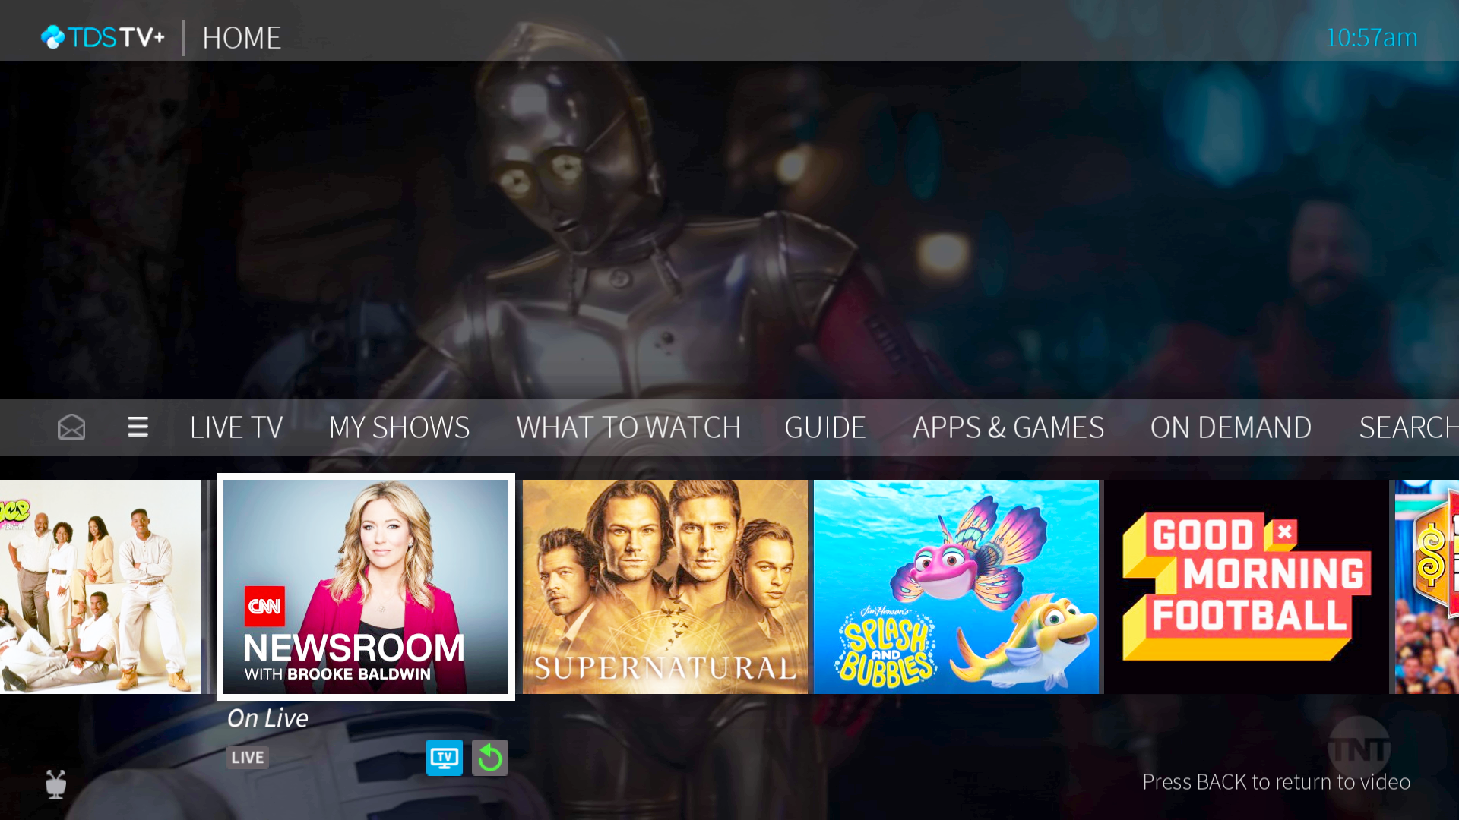

Caption: TDS Telecom goes live with Velocix for IP video streaming and Cloud DVR services

About TDS Telecom
TDS Telecommunications LLC (TDS Telecom/TDS) delivers high-speed internet, TV entertainment, and phone services to nearly 900 rural, suburban, and metropolitan communities across the U.S. With more than 1.2 million connections, TDS is one of the fastest growing technology companies in the United States. Powered by fiber-optics and new industry-leading technologies, TDS delivers up to 1 Gigabit internet speeds and offers internet-protocol based TV entertainment solutions along with traditional phone services. TDS also offers businesses VoIP advanced communications solutions, dedicated internet service, data networking, and hosted-managed services. Visit tdstelecom.com.

About Velocix
Velocix is the world’s leading provider of content delivery, origin and storage, and stream personalisation software and we are Making Video Personal, on every connected screen. Our technology is used to engage, entertain, and inform millions of people around the globe, every single day. We help consumers connect with the content they love by building products that are more responsive to personal viewing preferences, making every video experience more rewarding. We work closely with our customers, including telecommunications, cable, and online video service providers, to help them navigate a rapidly changing video market, so they can lead the transformation, compete more effectively, and grow their businesses. Visit velocix.com
For further information, please contact:
Jim Brickmeier, CPO/CMO, Velocix
+1 404 964-8495 | jim.brickmeier@velocix.com

Neil Sharpe, Head of Product Marketing, Velocix
+44 7876 828 286 | neil.sharpe@velocix.com

